**Yahoo Finance Web Scraper Instructions**

The Yahoo Finance web scraper is a command line tool that allows users to download data for any ticker(s) of their choosing from Yahoo Finance.

***Note to Mac/Apple Users:***

Unfortunately, the .exe file I have compiled may not work on Mac computers. If anyone is interested in compiling an .exe for Mac the following is a link to the Github repo that contains the actual python script. <https://github.com/TheCynicalBadger/Yahoo-Finance-Scraper-Console-Python>

You will need the following dependencies: the python library, yfinance, pandas, os, and time. The .exe can be compiled using *pyinstaller* with the --clean --console --onefile options.

**Instructions:**

The most recent compiled version of the scraper can be found at the following link:  
<https://drive.google.com/drive/folders/1kEn3DL9odl8BiLw9ZVhb4mJlGx5rUGNm?usp=sharing>

1. Users must begin by downloading the most recent version of the .exe file from the Google Drive link above. Since the file is an executable, Google Drive may warn you that you are downloading a potentially hazardous file. Below is an example of that warning. Click on the “Download Anyway” button to proceed.

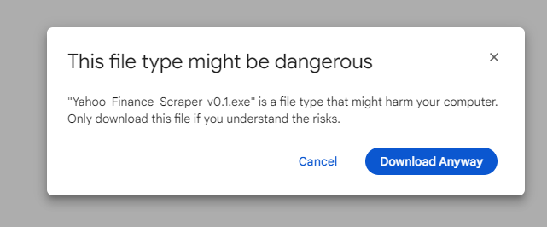

1. After downloading the file, users can simply open the file and the web scraper will run. However, the first time the user uses the scraper after downloading they will have to take some additional steps. Windows will tell the user that the app is unrecognized and it has been blocked. An example of that screen is below:

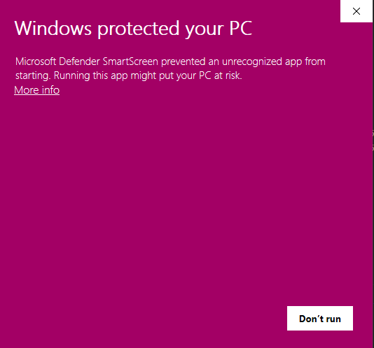

Users can bypass this safeguard by clicking “more info” at which point a new button will appear that says “Run anyway.” Select run anyway to continue.

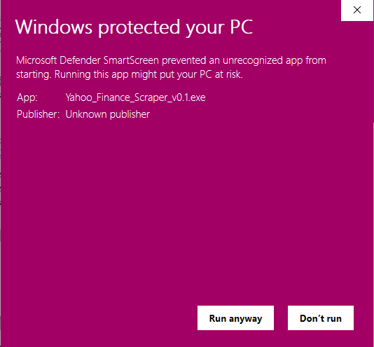

1. The app may take quite a while to load since it has been compiled into a single executable. It should not take more than 1 minute to open. Once the main console window opens, the app may take some time before it presents the user with a prompt. Once loaded, continue to step 4.
2. The first piece of information the scraper needs is a list of the tickers you would like to download. These tickers all need to be valid in order for the download to function properly. The tickers must be presented as a space delimited list. After entering your tickers, press enter and proceed to step 5.
   1. Example:
      1. I would like to download data for SPDR 500 ETF (SPY), Gold SPDR ETF (GLD), and Energy Sector SPDR ETF (XLE). In order to download this data I would need to input:  
         SPY GLD XLE  
         *Note that there are NOT quotes around the values you enter

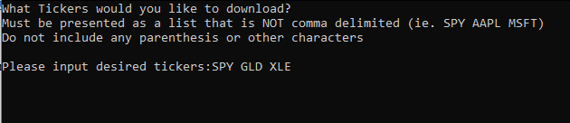

1. The next piece of information the scraper will ask for is the time period for which you would like data. The possible values for this field are 1D, 5D, 3M, 6M, YTD, 1Y, 5Y, and Max. If you were to enter “5Y” you would download the last 5 years of data for all the tickers you specified in step 4. After specifying your time period, press enter and proceed to step 6.
   1. Example:
      1. I would like to download the last 5 years of data for the tickers I specified in step 4. I would need to input:  
         5Y  
         *Note there is NO space between the 5 and the Y

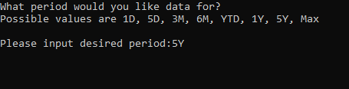

1. The final piece of information the scraper will ask for is the granularity or interval of the data you would like to download. This means that if I choose 1d, I will download the daily returns data for the tickers specified and the time period specified in steps 4 and 5. Possible values for this field are 1d, 5d, 1wk, 1mo, and 3mo. After specifying the interval of your data, press enter and proceed to step 7.
   1. Example:
      1. I would like to download data with a monthly interval for the tickers and time period I specified in previous steps. I would need to input:  
         1mo  
         *Note there is NO space between the 1 and the mo



1. After completing step 6 and proceeding, the app should download the data with the parameters you have specified. You should see “100%” with the number of tickers you downloaded next to it, in our example we downloaded 3 tickers so it says “3 of 3.” The scraper tells you the location of the data it saved by using a windows file path. Each file will have a timestamp for the time you downloaded the data, therefore each time you run the scraper its output will have a unique name.  
   The scraper downloads 2 different files, one of them is titled “all data” and the other is titled “returns only.” The returns only file is the calculated percentage return of each tickers adjusted closing price. The all data file is all the data that Yahoo Finance presents to a regular user.
   1. Example:
      1. In our example the returns only file contains this data:

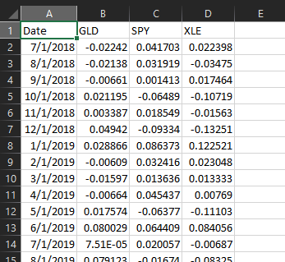

* + 1. In our example the all data file contains this data:

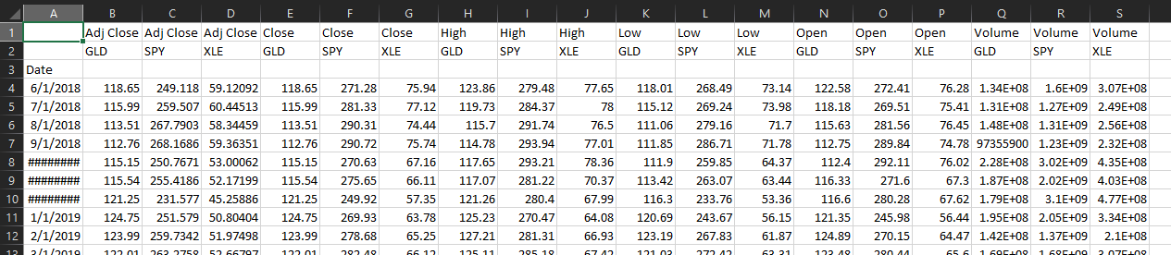

**Common Issues:**

If both of the output files are empty it is likely that you have incorrectly entered one of your parameters. Rerun the app using the same parameters however be careful with the way you have entered them.

Sometimes the scraper will produce “errors” after completing step 6. An example of an error is found below. Often times these errors are easily correctable by using the prompts found in the error message. In the below example, a space was added between 1 and mo for the interval.

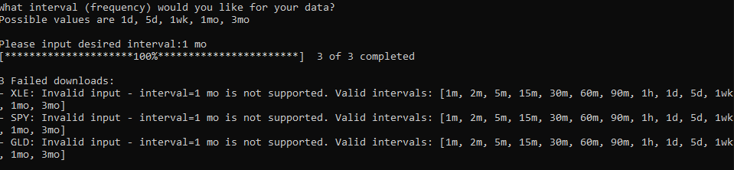

If you believe you are encountering an error that you cannot solve, please open an issue at the following link: <https://github.com/TheCynicalBadger/Yahoo-Finance-Scraper-Console-Python/issues> **However, please do not open an issue until you have made multiple attempts and have exhausted all available problem solving information.**